Chapter 1: Operating Systems and Linux Fundamentals

1.1 The Role of an Operating System
An Operating System (OS) is the fundamental system software environment that manages computer hardware and software resources, providing common system services for application programs. Without an OS, software programs must interface directly with bare-metal electronic circuity, implementing device-level operational drivers and processor instruction loops manually.

The operating system acts as both a resource allocator and an abstract interface provider:

- Hardware Abstraction Layer (HAL): Translates physical signaling and micro-architectural variance across CPUs, storage controllers, memory controllers, and peripheral expansion buses into unified, standardized software APIs (Application Programming Interfaces).
- Arbitration and Isolation: Mediates competing resource requests among multiple running processes, ensuring deterministic access, bounded latency, and memory safety through hardware privilege boundaries.
- Control Program Execution: Prevents hardware misuse, crashes, and unauthorized configuration alterations by restricting direct access to peripheral controllers and system configurations.

Hardware-Software Interaction Pipeline
The operational pipeline flows unidirectionally across hardware privilege tiers:

- Bare-Metal Hardware: Microprocessors (CPU), Dynamic Random-Access Memory (DRAM), System Busses (PCIe, SATA, NVMe), and Peripherals (NICs, GPUs, storage arrays).
- Kernel Core: Executes in privileged execution mode (Supervisor/Ring 0), managing instruction queues, register mapping, and device interrupts.
- Hardware Abstraction Layer (HAL) & Drivers: Translates register reads/writes into generic operational routines (read(), write(), ioctl()).
- System Call Interface (SCI): The gateway connecting user space (Ring 3) to supervisor state via software interrupts (int 0x80 or syscall).
- System Libraries (GNU C Library / glibc): Exposes C standard wrapper functions conforming to the POSIX (Portable Operating System Interface) standard.
- User Space Applications: Command-line shells, system daemons, compilers, desktop environments, and web servers.

1.2 The Four Core Operating System Subsystems
The Linux kernel decomposes hardware orchestration across four interconnected architectural subsystems.

Subsystem | Core Responsibilities | Key Kernel Data Structures & APIs
Process Management | Allocates CPU time across computational threads; implements scheduling policies; maintains execution states (TASK_RUNNING, TASK_INTERRUPTIBLE, TASK_STOPPED, TASK_ZOMBIE); manages task context switching. | task_struct, Completely Fair Scheduler (CFS), fork(), clone(), execve(), waitpid()
Memory Management | Allocates physical DRAM frames; translates virtual addresses to physical space via multi-tier page tables; enforces per-process address space isolation; manages page swapping to persistent storage. | mm_struct, Translation Lookaside Buffer (TLB), Virtual Memory Areas (vm_area_struct), Page Table Entries (PTE), Demand Paging
File System Management | Translates logical directory paths into block device storage offsets; implements structural metadata allocation; manages sector buffering and cached block write-backs; presents unified hierarchical tree structures. | Virtual File System (VFS), Inodes, Dentries, Superblocks, File Operations Structs (file_operations)
Device I/O Management | Manages block, character, and network drivers; surfaces abstracted unified nodes inside the virtual file system; coordinates Direct Memory Access (DMA); handles IRQ lines and deferred interrupts (Bottom Halves / Tasklets). | Device files (/dev), Device Mapper, sysfs (/sys), procfs (/proc), Interrupt Service Routines (ISRs)

Process Lifecycle and the Scheduler
The Linux Process Manager uses the Completely Fair Scheduler (CFS) for non-real-time operations, balancing execution time across running threads using red-black self-balancing trees. Every running execution context is tracked by a massive kernel structure named task_struct.

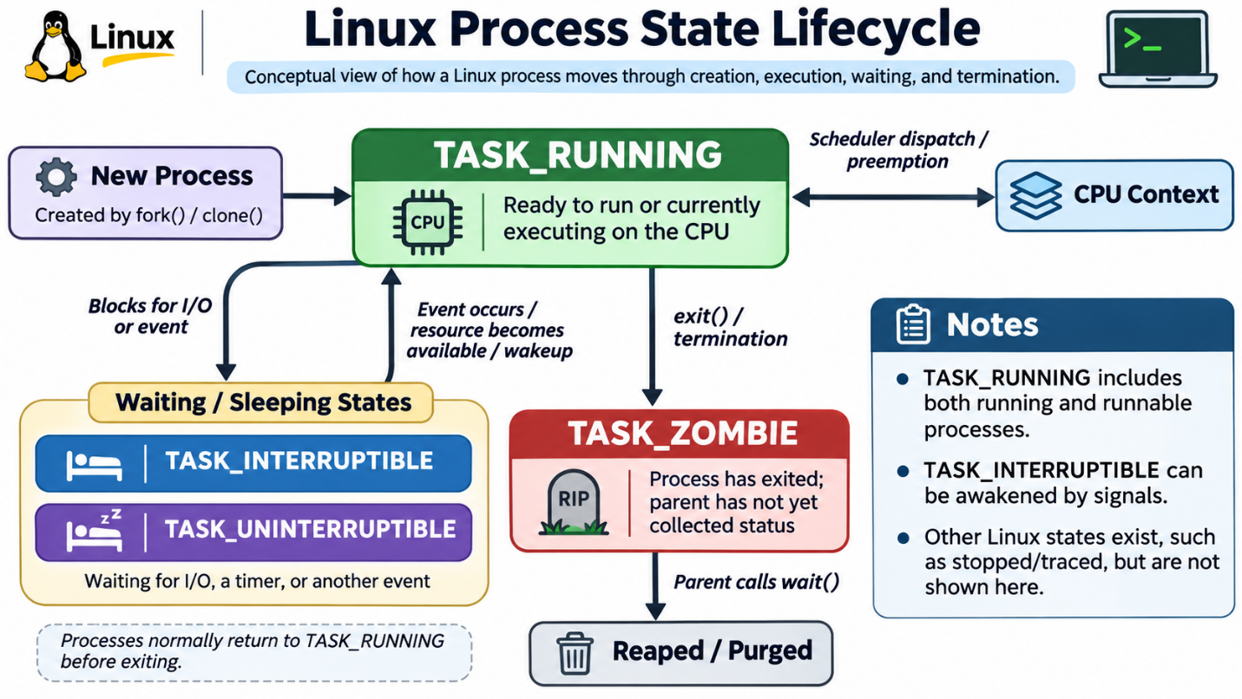

Memory Virtualization and Paging
Linux uses a virtual memory architecture to prevent processes from modifying physical memory allocated to other applications or to the kernel core.

- The CPU's Memory Management Unit (MMU) handles runtime address translation.
- Memory is segmented into fixed-size units known as pages (traditionally 4 KiB on standard architectures).
- Virtual memory addresses map to physical memory frames via page tables. If a process addresses an offset residing in swapped persistent storage rather than DRAM, the MMU triggers a Page Fault, prompting the kernel to fetch the missing page synchronously from the block storage device.

The Virtual File System (VFS)
The Virtual File System creates a common abstraction model over heterogeneous storage backends (ext4, XFS, Btrfs, NFS, FAT32):

- Superblock Object: Tracks high-level filesystem metrics (geometry, inode counts, block size, status flags).
- Inode Object: Represents a distinct physical filesystem entity containing metadata (permissions, ownership, size, hardware block disk pointers). Inodes do not store the file's text name.
- Dentry (Directory Entry) Object: Couples directory strings to corresponding inode numbers, accelerating path string lookups via directory entry caches.
- File Object: Tracks an open instance of a file associated with an active process (file pointer offsets, read/write flags).

1.3 Linux Deployments in Modern Computing
While consumer exposure often associates personal computing with proprietary graphical operating systems, the Linux kernel serves as the base layer for modern enterprise infrastructure.

Supercomputing and High-Performance Computing (HPC)
Every system in the global TOP500 supercomputing cluster rankings runs Linux. This dominance stems from:

- Kernel parameter customizability and modularity (compiling out non-essential subsystems to minimize cycle overhead).
- Unmatched scalability across non-uniform memory access (NUMA) nodes and high-density parallel processing units.
- Direct kernel hooks for Remote Direct Memory Access (RDMA) and low-latency InfiniBand interconnect fabrics.

Cloud Computing, Containerization, and Microservices
The cloud ecosystem relies on Linux kernel primitives:

- Namespaces: Provides virtual process isolation across PID trees, network interfaces, mounts, and user mapping.
- Control Groups (cgroups): Meters, throttles, and tracks physical hardware allocation (CPU cores, DRAM allowances, block I/O throughput).
- Containers: Engines like Docker and orchestrators like Kubernetes run isolated user spaces atop a shared Linux host kernel. This removes the hardware emulation layers and resource overhead required by traditional Type-2 Hypervisor virtualization.

The Internet of Things (IoT) and Embedded Hardware
Linux scales down to low-power platforms through projects such as Buildroot, OpenWrt, and Yocto:

- Network gateways, enterprise switches, home automation hubs, automotive telematics, and medical avionics use stripped-down, customized Linux builds.
- Software layers can compile on low-power architectures including ARM, RISC-V, and MIPS with sub-32-megabyte RAM profiles.

Android Mobile Ecosystem
Google's Android utilizes a downstream, Long Term Support (LTS) Linux kernel:

- Linux provides hardware abstraction, process scheduling, power management routines (Wakelocks), and process isolation.
- The proprietary GNU userland toolchain is replaced by the Android Open Source Project (AOSP) framework: the Bionic C standard library replaces glibc, and the Android Runtime (ART) executes Ahead-Of-Time (AOT) compiled Dalvik bytecode within sandboxed, per-app user IDs.

1.4 User Interfaces: Graphical (GUI) vs. Command-Line (CLI)
Interfacing with the underlying kernel runtime occurs through two computational paradigms: graphical windowing systems or declarative textual shell terminals.

Metric / Dimension | Graphical User Interface (GUI) | Command-Line Interface (CLI)
System Overhead | High: Requires display server runtimes (X11/Wayland), GPU accelerated compositors, high memory allocations for visual buffers. | Minimal: Text stream processing requires negligible RAM (kilobytes to megabytes) and zero GPU hardware acceleration.
Throughput & Speed | Limited by manual input speeds: Moving pointing devices, waiting on window transitions, locating graphical sub-menus. | High: Experienced administrators can invoke complex pipeline routines instantly via chained commands and regular expressions.
Automation Potential | Low: Automating graphical workflows requires brittle mouse coordinate mapping or synthetic visual frame analysis. | Native: Everything exposed via a CLI accepts standard input, yields standard output, and can be batched into shell scripts.
Remote Management | Demands high-bandwidth network pipelines (VNC/RDP) that struggle over high-latency connections. | Optimized: Encrypted terminal connections via Secure Shell (SSH) transmit pure text payloads, functioning over low-bandwidth links.
Learning Curve | Low: Discoverable visual affordances, desktop icons, and interactive visual feedback lower initial barriers to entry. | High: Demands precise syntax retention, understanding standard Unix file parameters, and reading manual pages.

1.5 Linux Desktop Environments
When a graphical desktop is installed, Linux systems separate the core operating system logic from the visual presentation layer. The graphical stack uses a display server protocol (X11 or Wayland), a window manager, and a comprehensive suite of utilities that together form the Desktop Environment (DE).

GNOME
- Primary Target: Workstation usability, modern minimalism, visual consistency.
- Base Toolkit: GTK (GIMP Toolkit).
- Resource Profile: High memory and graphics requirements.
- Architecture: Centered around the Clutter and Mutter compositing managers; relies heavily on an application-agnostic top shell bar, gesture-driven multi-workspace switching, and dynamic desktop extensions. The default environment for Enterprise distributions like RHEL, CentOS Stream, Fedora, and Ubuntu Desktop.

KDE Plasma
- Primary Target: Deep customizability, granular user control, high-performance visual aesthetics.
- Base Toolkit: Qt.
- Resource Profile: Moderate to lightweight footprint despite rich visual compositing (KWin).
- Architecture: Modular architecture based on Plasma Widgets (Plasmoids). Exposes fine-grained adjustments for window behavior, application themes, display protocols, and peripheral scaling. Includes the KDE Applications framework.

Xfce
- Primary Target: Resource efficiency, stability, predictable desktop layout paradigms.
- Base Toolkit: GTK.
- Resource Profile: Low resource usage. Well-suited for legacy hardware, virtual desktop instances, and thin clients.
- Architecture: Adheres strictly to traditional Unix desktop conventions. Avoids hardware 3D composition dependencies by using modular binaries: xfwm4 (window manager), xfce4-panel (panel manager), and thunar (file manager).

LXQt
- Primary Target: Minimal hardware footprint, high operational speed, low energy consumption.
- Base Toolkit: Qt (the modern merge of LXDE-Qt and Razor-qt).
- Resource Profile: Extremely light memory and CPU footprint.
- Architecture: Removes compositing overhead and background daemon bloat to operate efficiently within constrained DRAM limits (such as single-board computers and legacy systems).

Cinnamon
- Primary Target: Desktop ergonomics, visual appeal, ease of transition for traditional desktop users.
- Base Toolkit: GTK (originally forked from GNOME 3).
- Resource Profile: Moderate memory and CPU utilization.
- Architecture: Developed by the Linux Mint team. Features a traditional layout: bottom taskbar, system status tray, and structured, categorized application launch menu.

1.6 The Historical Evolution of Unix, GNU, and Linux
Modern enterprise Linux environments are the direct result of three historical software movements converging over several decades.

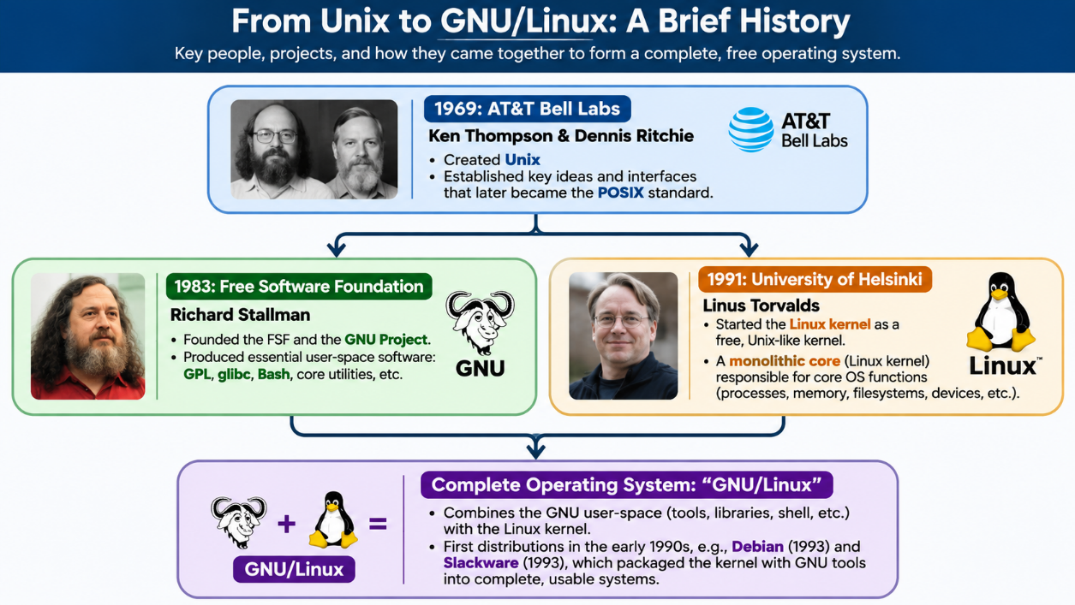

The Unix Heritage
In 1969, Ken Thompson, Dennis Ritchie, and fellow researchers at AT&T Bell Laboratories designed Unix. The platform introduced key design principles that remain central to modern systems architecture:

- Modularity: Write programs that do one specific task and do it well.
- Text Streams: Design programs to handle text streams, which serve as a universal communication interface.
- Unified File System Abstraction: Abstract system resources—including peripherals, serial ports, and network channels—as readable/writable file descriptors ("everything is a file").

Unix became the computational standard for enterprise data centers and academic institutions. However, AT&T's subsequent commercialization and proprietary licensing models led to platform fragmentation, code secrecy, and restrictive access.

The GNU Project and Free Software Ideology
In 1983, Richard Stallman founded the Free Software Foundation (FSF) and launched the GNU Project (a recursive acronym for "GNU's Not Unix"). Stallman's goal was to build a complete, non-proprietary, Unix-compatible operating system.

By 1990, the GNU Project had built almost all the core software layers required for a complete operating system:
- The GNU C Compiler (gcc)
- The GNU C Library (glibc)
- The Bourne Again Shell (bash)
- The GNU Core Utilities (coreutils: ls, cat, grep, cp)

However, the GNU microkernel project—GNU Hurd—faced extended development bottlenecks and remained non-viable for real-world production deployments.

Linus Torvalds and the Linux Kernel
In August 1991, Finnish computer science student Linus Torvalds sought to build a functional, monolithic operating system kernel for his Intel 80386 personal computer. Torvalds sought an alternative to the Minix educational environment and proprietary Unix implementations.

Torvalds combined his functional monolithic kernel (capable of memory management, task switching, and device interfacing) with the GNU Project's userland tools, compilers, and utilities. This pairing formed a completely free, Unix-compatible operating system commonly called GNU/Linux.

The GNU General Public License (GPL) and Copyleft
Central to Linux's longevity and stability is its licensing framework: the GNU General Public License Version 2 (GPLv2).

- Permissive Licenses (e.g., BSD, MIT, Apache): Grant developers permission to modify source code and redistribute the resulting software binaries without being obligated to share their modified source code.
- Copyleft (Reciprocal) Licenses (e.g., GPLv2): Require any party who redistributes the software, with or without changes, to pass along the freedom to further copy and modify it. Anyone who distributes modified versions of GPLv2-licensed code must make their complete source code modifications available to down-stream recipients under identical GPLv2 terms.

The GPLv2 stopped hardware vendors and software firms from closing off the Linux kernel source tree into proprietary, single-vendor forks. Any improvements made to core kernel subsystems by commercial entities must be contributed back to the broader developer community if distributed, ensuring long-term code health.

1.7 Architectural Foundations: The 4-Layer Hierarchy
Enterprise Linux architecture is organized into four foundational operating layers: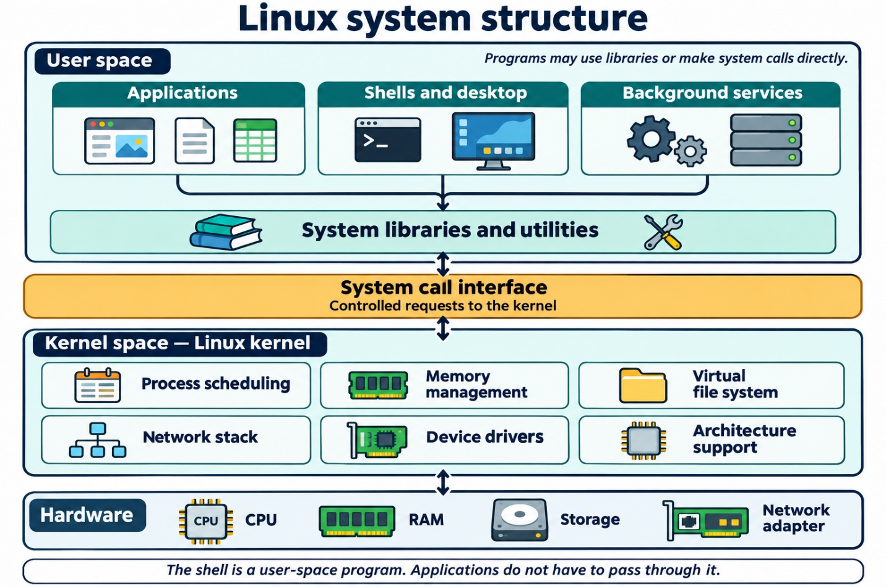

1. Physical Hardware (Bare-Metal)
The raw computing substrate consisting of CPUs, memory controllers, random access memory modules, NVMe/SATA storage drives, and PCIe network interface peripherals.

2. The Linux Kernel Core
The kernel operates in Supervisor Mode (Ring 0). It retains unrestricted access to physical CPU instruction sets and raw memory blocks. While modern operating systems run dynamic runtime modules, the Linux kernel is predominantly monolithic: virtual memory management, CPU scheduling routines, and peripheral drivers execute within the single high-privileged supervisor address space.

3. System Utilities, Daemons, and Toolchains
Operating in User Mode (Ring 3), this layer provides base operational utilities. This includes init architectures and process supervisors (such as systemd), shell command interpreters (bash), network connection brokers, administrative scheduling daemons (cron), and the runtime C library (glibc). Programs running in user space cannot interact directly with the hardware; they must request actions by passing execution parameters through the system call boundary.

4. User Space Applications
Top-level productivity, business logic, enterprise database servers, web engines, and graphical end-user software (e.g., Apache HTTPD, Nginx, PostgreSQL, Python runtimes, LibreOffice, Firefox).

1.8 Selecting an Enterprise Distribution
A Linux Distribution ("distro") packages the upstream Linux kernel with userland tools, package managers, network configurations, default security policies, and technical support frameworks into an integrated operating system.
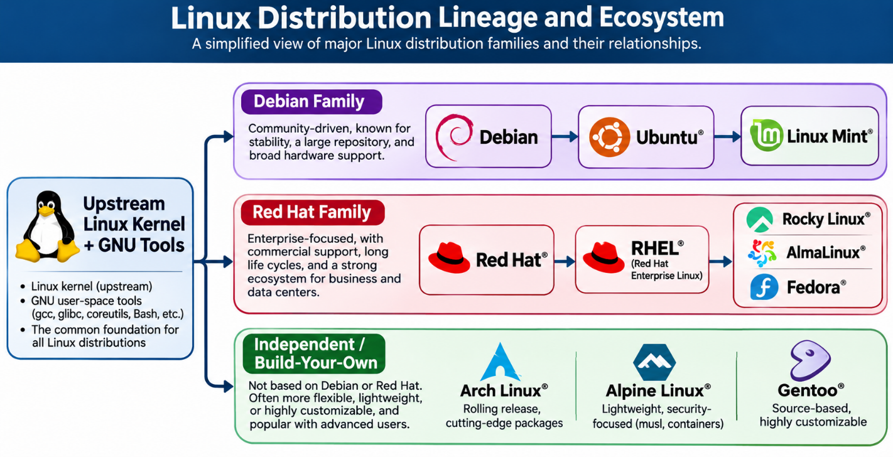
Enterprise deployment choices balance software currency against runtime stability:

- Debian / Ubuntu Server Family:
  - Uses the .deb package format and the apt/dpkg package management systems.
  - Debian favors conservative, production-proven stability.
  - Ubuntu features a predictable Long-Term Support (LTS) lifecycle released every two years, backed by Canonical. A common choice for cloud compute instances, edge installations, and web services.
- Red Hat Enterprise Linux (RHEL) Family (Rocky Linux, AlmaLinux, Fedora):
  - Uses the .rpm package format and the dnf/rpm package managers.
  - Standard for finance, institutional computing, defense platforms, and on-premises enterprise data centers.
  - Fedora serves as Red Hat's rapid-iteration upstream pipeline. Rocky Linux and AlmaLinux deliver direct binary compatibility with upstream RHEL, providing alternative production options that do not require licensing subscriptions.
- Arch Linux / Alpine Linux:
  - Arch Linux: Employs a rolling-release cadence where software updates deploy continuously without discrete version migrations. Common among power users, engineers, and specialized workstations.
  - Alpine Linux: A stripped-down distribution built around the musl C library and busybox. Commonly used as a base image for production cloud containers due to its minimal footprint (often under 8 MB) and reduced attack surface.

1.9 Hands-On Lab: Installation and Post-Installation System Inspection
This laboratory exercise walks through preparing an enterprise Linux instance, configuring basic parameters, and validating kernel subsystems through the shell terminal.

Part 1: Deployment & Base Configuration
- Initialize a modern 64-bit virtualization hypervisor (e.g., VirtualBox, VMware Workstation, or KVM/QEMU).
- Attach an official installation ISO (e.g., Ubuntu Server LTS or Rocky Linux Minimal).
- Allocate base virtualization parameters:
  - CPU: 2 vCPU cores
  - System RAM: 4096 MB (4 GiB)
  - Virtual Block Storage: 25 GiB dynamically allocated drive
- Walk through the guided installer:
  - Localization: Set base language, keyboard mapping, and primary network location.
  - Storage Partitioning: Use the standard GUID Partition Table (GPT) scheme:
    - Mount point /boot/efi: 512 MiB partition formatted with standard FAT32 (UEFI bootloader staging).
    - Mount point /boot: 1024 MiB formatted with ext4 (Linux kernel payloads and initial RAM disks).
    - Mount point /: Remaining disk space allocated as an ext4 or XFS primary root volume.
  - Identity Configuration: Assign a system hostname (station-01), configure an administrative user account (adminuser), and assign a secure alphanumeric passphrase. Select Install OpenSSH Server for remote shell management.
- Apply settings and complete the installation. Reboot the system and remove the installation ISO.

Part 2: Administrative System Inspection
Log into the terminal console as your configured user. Execute the following inspection commands to analyze the underlying architecture, kernel status, and attached hardware:

1. Checking the Running Kernel Version

uname -a

- Command Breakdown: uname (unix name) queries kernel build variables. The -a flag requests all available metadata: the kernel classification name (Linux), network hostname, active kernel release version, compilation date, architecture targets (x86_64), and the base operating system platform.

2. Determining Operating System Distribution Details

cat /etc/os-release

- Command Breakdown: cat (concatenate and display) reads the contents of the /etc/os-release file. This standard system file contains the active Linux distribution's name, version numbers, support documentation links, and upstream family lineage.

3. Analyzing CPU Micro-Architecture

lscpu

- Command Breakdown: Collects CPU architecture details from sysfs and /proc/cpuinfo. This output lists logical core counts, socket configuration, operational frequencies, cache sizes (L1d, L1i, L2, L3), virtualization capabilities, and hardware-level vulnerability mitigations (e.g., Meltdown, Spectre).

Auditing Physical and Virtual Memory Allocations

free -h

- Command Breakdown: Displays total, allocated, free, shared, and available physical memory along with swap allocations. The -h flag converts machine byte values into human-readable denominations (e.g., MiB, GiB).

5. Inspecting Block Storage and Filesystem Hierarchies

lsblk

- Command Breakdown: Lists active block devices, their partition layouts, major/minor device numbers, storage capacity, and their respective VFS mount points.

df -Th

- Command Breakdown: df reports filesystem disk space usage. -T displays the filesystem type (e.g., ext4, xfs, btrfs), while -h displays sizes in human-readable units.

6. Inspecting Peripheral Bus Interconnects

lspci

- Command Breakdown: Queries the PCI bus, listing all host bridges, storage controllers, network cards, USB interfaces, and virtual graphical display adapters identified by the kernel.

1.10 Chapter Key Terms Glossary
- Operating System (OS): Core system software that manages physical hardware, controls peripheral access, provides isolation boundaries, and provides execution APIs for application software.
- Linux Kernel: The core monolithic supervisor program created by Linus Torvalds in 1991. It manages process scheduling, memory allocation, and hardware I/O directly within privileged CPU space.
- Hardware Abstraction Layer (HAL): An internal software framework that hides hardware-specific register sets and interfaces behind standardized software APIs.
- POSIX (Portable Operating System Interface): A family of IEEE standards defining API system calls, utility programs, and shell environments. It ensures source code compatibility for software across diverse Unix and Linux variants.
- GPL (GNU General Public License): A copyleft free software license authored by Richard Stallman. It grants full rights to use, modify, and redistribute code, provided all downstream public variations maintain the same open licensing terms.
- Completely Fair Scheduler (CFS): The standard Linux kernel CPU scheduling algorithm for non-real-time processes. It balances runtime execution using red-black computational search trees.
- Virtual Memory: A memory management architecture that abstracts physical DRAM into separate, contiguous address spaces for each process, enforcing runtime protection boundaries.
- Paging: A memory management mechanism that breaks physical memory and address spaces into fixed-size blocks (typically 4 KiB), swapping content between RAM and persistent storage as needed.
- Page Fault: An interrupt raised by the CPU Memory Management Unit when a program attempts to access a virtual page that is not currently mapped into physical DRAM.
- Virtual File System (VFS): An abstraction layer inside the Linux kernel that provides standard system calls (open(), read(), write()) across disparate, underlying filesystem formats.
- Inode: A filesystem data structure that stores metadata about a file or directory (e.g., size, permissions, owner, hardware data block locations), excluding its filename string.
- Containerization: An operating system-level virtualization method that groups processes into isolated environments using Linux kernel namespaces and cgroups, without running a hypervisor.
- Namespaces: A Linux kernel feature that isolates system resources for sets of processes (e.g., process IDs, network interfaces, filesystem mount points).
- Control Groups (cgroups): A Linux kernel feature that limits, meters, and isolates the physical resource usage (such as CPU, memory, and disk I/O) of process groups.
- Display Server Protocol: A software communication protocol (such as Wayland or X11) that manages input events and coordinate pipelines between the window manager, applications, and graphical displays.
- Desktop Environment (DE): A complete, cohesive graphical interface layer bundled with a display manager, window manager, visual theme engine, and integrated desktop utilities.
- Linux Distribution: An integrated operating system package combining the upstream Linux kernel, GNU tools, package managers, system daemons, and configuration profiles for target use cases.

1.11 Concept Review Questions
- Explain the architectural difference between an operating system operating as a resource allocator versus functioning as a hardware abstraction layer (HAL).
- Describe the operational relationship between the system call interface (syscall) and the hardware privilege levels of modern CPUs (such as Ring 0 vs. Ring 3).
- Trace the operational lifecycle of a standard Linux process from initial generation via fork() or clone() through execution, blocked I/O wait states, and final termination cleanup by a parent process.
- How does the Virtual File System (VFS) allow administrative users to run standard commands like ls or cat uniformly across different storage formats (such as ext4, XFS, and network NFS shares)?
- Detail how the Linux kernel uses Namespaces and Control Groups (cgroups) to support container runtimes like Docker, and contrast this with traditional Type-2 hardware hypervisor virtualization.
- Compare modern Android with standard enterprise GNU/Linux distributions. Identify the architectural components Android keeps from upstream Linux, and the specific layers it replaces.
- Outline the core differences between copyleft software licenses (such as the GNU GPLv2) and permissive open-source licenses (such as MIT, BSD, or Apache). Explain how the GPL protected the Linux kernel ecosystem from proprietary fragmentation.
- Describe the performance, maintenance, and administrative tradeoffs of managing a production server fleet through a Command-Line Interface (CLI) versus a Graphical User Interface (GUI).
- Explain how Desktop Environments separate functional responsibilities between the underlying display server protocol (X11 or Wayland), the window manager, and the desktop framework.
- What specific technical, functional, or business criteria would lead an organization to choose an Enterprise Linux distribution (like RHEL or Rocky Linux) over an edge-focused distribution (like Alpine Linux)?

1.12 Lab Reflection and Analysis Questions
- In the system inspection lab, you executed uname -a. Identify the individual fields returned by this command and explain how an administrator can use this information to maintain security patches.
- Examine the information in /etc/os-release. Why is it important for deployment scripts and configuration management tools (such as Ansible) to read this file before running system updates?
- In the CPU audit step using lscpu, explain the practical difference between physical CPU sockets, hardware CPU cores, and logical execution threads.
- When reviewing memory usage with free -h, explain the difference between the free and available columns. Which metric better indicates if a system is running out of physical DRAM, and why?
- Look at the disk usage output from df -Th. Why does the sum of the used and available storage space across a partition often fail to match the total disk size reported by lsblk?
- Detail why modern UEFI system configurations require a separate /boot/efi partition formatted specifically in FAT32, rather than using standard Linux native filesystems like ext4 or XFS.
- In the peripheral audit step using lspci, describe how the Linux kernel identifies newly attached hardware on the system expansion bus and maps those devices to their corresponding driver modules.
- Assume you were tasked with deploying 500 minimal virtual machines running on constrained, low-memory hypervisor nodes. Based on your lab findings and the reading in this chapter, which Linux distribution family and user interface configuration would you choose, and why?

